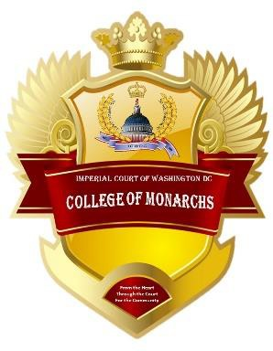

Phoenix Award

**Presented by The College of Monarchs of the ICWDC**

The Phoenix Award is dedicated to Phoenix Jewel who was a lifetime title holder of the Imperial Court of Washington DC. Phoenix was an inaugural member of the ICWDC and held several board positions. Phoenix held the position of Minister of Protocol longer than any member and he did the job with the utmost dignity, respect and admiration for all.

The College wanted to honor his memory by creating an award to be given out each year on Coronation weekend.

Phoenix was a mentor to many and was always there to guide and teach anyone who was willing to learn. But more importantly Phoenix was “Daddy” to many.

Phoenix was always striving to better the court and inspired many others to do the same. His dedication was unparalleled to anyone.

The Phoenix award will be for those that the college recognizes who follow in Phoenix’s steps and inspire others to be their true selves and move the court into the future with dedication and determination.

This award will be given to any member of the International Court System and/or The Imperial Court of Washington, DC Realm community.

Appendix Q